New Standard

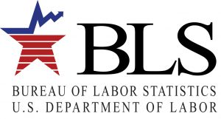
The Bureau of Labor Statistics has approved for 2018 a separate definition for Surgical Assistants.

This is the accepted definition as it is listed:

29-9093 Surgical Assistants Assist in operations, under the supervision of surgeons.
May, in accordance with State laws, help surgeons to make incisions and close surgical sites, manipulate or remove tissues, implant surgical devices or drains, suction the surgical site, place catheters, clamp or cauterize vessels or tissue, and apply dressings to surgical site. Excludes "Registered Nurses" (29-1141) and "Surgical Technologists" (29-2055)

